OFDM Channel Estimation

By Daniel Paz

Table of Contents

OFDM Signal 3

Back Rotation of the Data 5

Filters Bank 6

Basic Estimation Algorithms 7

Common Processes 9

Spatial Smoothing 9

QR Decomposition 10

Eigen Decomposition 11

Signal Rank Estimation 12

Minimum Description Length 12

Eigenvalues derivative 12

Signal and Noise Decomposition 14

Noise Covariance Whitening 14

Peak Thresholding 15

Delay Spread Estimation Algorithms 16

Channel Tap Delays Estimation 16

Modified MVDR 16

MUSIC - Inverse 17

MUSIC - Roots 19

ESPRIT 21

Modified OMP 23

Channel Tap Phasors Estimation 26

Channel Delay Spread Estimation Performance 26

Doppler Spread Estimation Algorithms 27

ACF FFT 28

ACF Sub-Space 28

Estimated Delay Taps Sub-Space 29

Channel Doppler Spread Estimation Performance 29

References 30

[1]: Determining the number of signals by information theoretic criteria 30

[2]: Channel Estimation for OFDM Signals 30

[3]: Performance of ESPRIT and Root-MUSIC for Angle-of-Arrival(AOA) Estimation 30

[4]: Doppler spread estimation in high mobility wireless communication - Zichen Wang 30

# OFDM Signal

The ODFM signal is an IFFT over the data symbols in frequency domain



The received signal is:



If we activate an FFT back to the frequency domain:





We can see that if the longest multipath is longer that the guard interval  we get ISI.

We are now dealing with **No ISI** case.

The matrix representation of a base-band discrete model:



If the is not on the grid of the FFT than we get a leakage of energy to other time bins:





Where:



We have implemented a simulation that generates the Rayleigh channel in frequency and time domains:

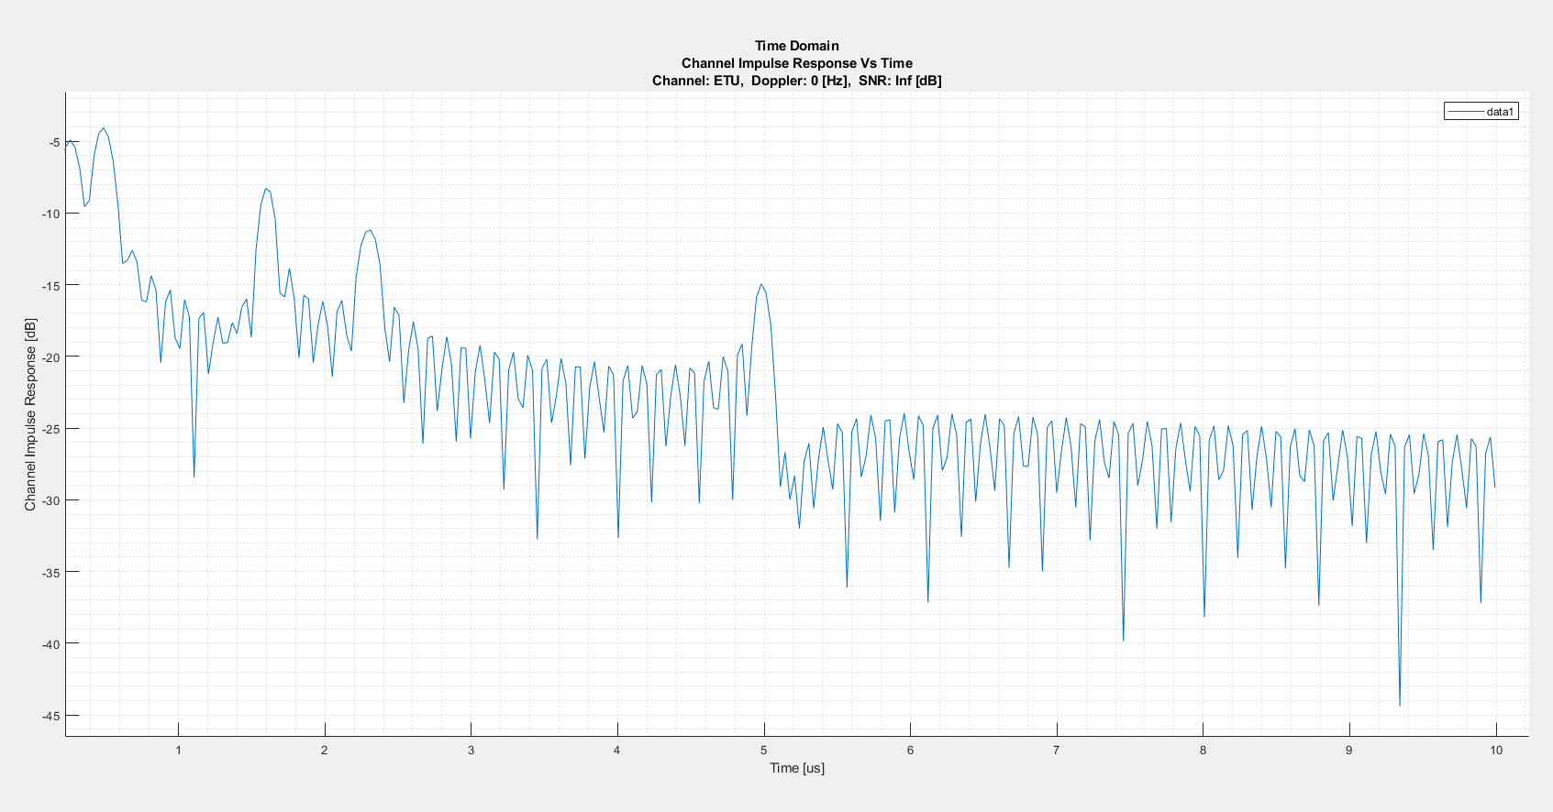

Here we can see an example of a channel ETU in the time domain. We can see that the channel has time delay taps up to 5[us]. These tap delay times are the 

So, in matrix representation we get:



# Back Rotation of the Data

If we back rotate the input signal with the data D (we assume we know the data in the pilot REs):



The Matrix  holds the transmitted data. Usually, we know it in the pilots’ REs.

# Filters Bank

In this work we deal with the channel estimation based on the pilots, and when we estimate the delay and doppler spread we can use filters bank to estimate the channel on all the other resource elements without the pilots using least squares solution.

We generate  realizations of the channel (AWGN, EPA, ETU) over different SNRs and doppler spreads.

The desired generated channel frequency response on the resource elements is:



The back-rotated input noisy signal is:



The coefficients matrix that estimates the desired channel frequency response in the desired REs based on the noisy signal is:





In other word we wish to find a coefficients matrix:



When we generated  realizations we have the following cost function:



We solve the least squares solution:



For the filters bank to be accurate we need to estimate the delay and doppler spread and generate channel realizations of these estimations.

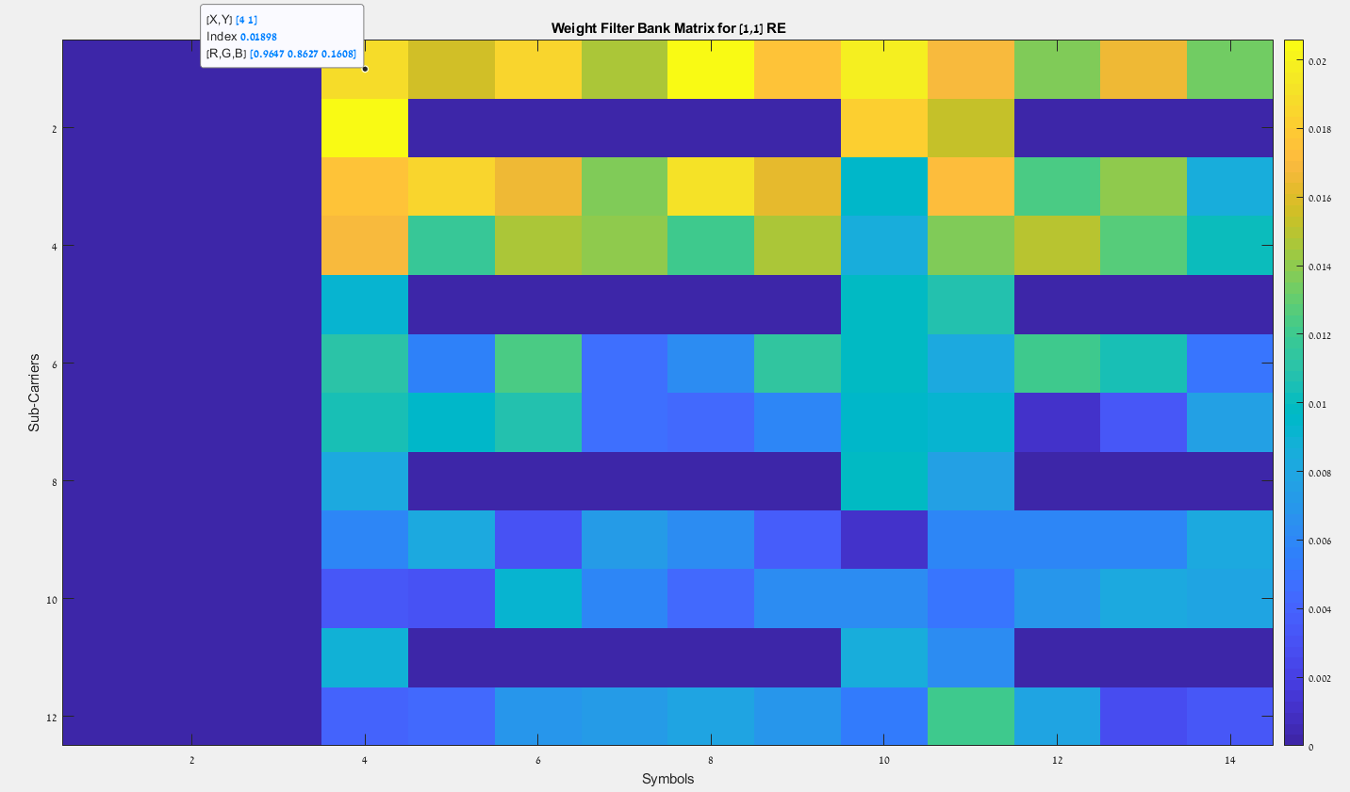

# Basic Estimation Algorithms

The first algorithms we used are the: LS and LMMSE:





The trade-off between Least Squares (LS) and Minimum Mean Square Error (MMSE) estimators primarily revolves around complexity versus performance under noise. LS is simpler and computationally less demanding but may perform worse in noisy conditions as it doesn't explicitly account for noise characteristics. MMSE, on the other hand, incorporates noise statistics for estimation, potentially offering better accuracy at the cost of increased computational complexity and the need for prior knowledge about noise characteristics.

To estimate the channel taps covariance matrix we need to generate about  channel realizations:



We can optimize the performance by taking only the first L columns of since the multipath is limited to . So, we take the first:









The performance measurement we choose is:



Now we deal with a different family of algorithms, they all use the sub-space information of the received signal 

The signal  is drawn above. We generated an ETU channel with doppler 200[Hz]

This is the time response of the channel after FFT in the sub-carrier axes.

Most of the algorithms we use are of the super resolution type, mostly used for array signal processing for beam steering and angle of arrival estimation. The analogy is natural because the sub-carries of the OFDM are functioning exactly like ULA (Uniform Linear Array) of antenna receivers.

We will use the eigen decomposition of the OFDM symbols and use the signal sub-space, therefore we will need to perform a **spatial smoothing** of the covariance matrix.

# Common Processes

The following processes are common for almost all the suggested algorithms.

## Spatial Smoothing

Spatial smoothing is a technique used in array signal processing to enhance the performance of algorithms like MUSIC and ESPRIT in resolving closely spaced sources or signals in environments with correlated or coherent interference. It works by averaging across subarrays, effectively increasing the rank of the signal covariance matrix in scenarios with limited snapshots or coherent signals, thereby improving the estimator's ability to distinguish between sources. This technique can significantly enhance resolution and detection capabilities in challenging signal environments.

This process reduces the rank deficiency caused by coherent signals, as **each subarray sees a slightly different mix of the signals**. By averaging, the method exploits **spatial diversity**, **reducing the coherence between signals** and enhancing the signal matrix's rank, allowing better estimation of signal parameters like directions of arrival (DOAs).

The Eigen decomposition:



We assume that the number of signal driven eigen values are less than half of the total number of the eigen values, hence we use moving average on  of the size:



The number of sub-blocks we average is:



The forward smoothed covariance matrix is:



Now we also use backward spatial smoothing.

The motivation for using backward spatial smoothing, in addition to forward spatial smoothing, lies in its ability to further decorrelate coherent signals by exploiting the structure of the received signal matrix. By averaging both forward and backward processed data, it enhances the estimator's performance in identifying closely spaced sources and improves the robustness of DOA estimation algorithms, especially in environments with multipath propagation or in scenarios where signal reflections create coherent signal arrivals.

We define the flipped eye matrix:





And the forward backward spatial smoothed covariance matrix is:



At last, we apply diagonal loading for stability:



## QR Decomposition

Once we have the estimated covariance matrix  we will apply on it the eigen decomposition algorithm.

In Matlab we use “eig” but in real life we use the QR algorithm.

To boost the running time of the QR algorithm, we reduce the bottom-right element of  from the main diagonal of :



 directly uses the bottom-right element of  as the shift, which is a practical and often effective approximation of the Rayleigh quotient for the purpose of accelerating the QR algorithm. This method works particularly well when  is symmetric and the eigenvalues are real, as the matrix iteratively approaches a diagonal form where each diagonal element is close to an eigenvalue.

Let’s look at a general matrix 



We use the Grahm-Schmidt process:



The  matrices:



## Eigen Decomposition

In the eigen decomposition algorithm we use the QR decomposition above:



## Signal Rank Estimation

Signal rank estimation is crucial since we rely on the separation of the signal and noise subspace.

First, we sort the eigen values from the strongest to the weakest, such that:



We re-arrange the eigenvectors  respectively to the sorted eigenvalues.

During the research we used 2 main approaches:

### Minimum Description Length

The first algorithm we implemented “Minimum Description Length” (MDL) which is taken from the paper [1].





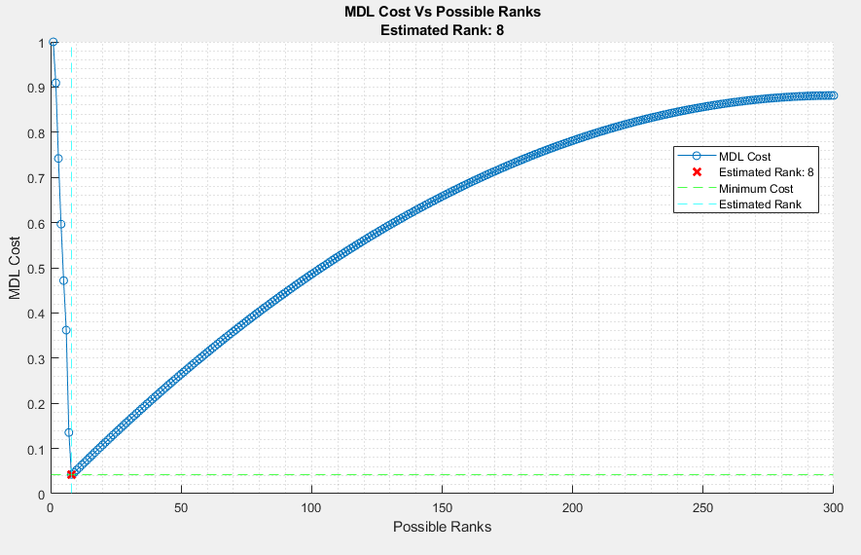

### Eigenvalues derivative

The second mechanism we suggest here is to look at the derivative of the eigen values and to compare it to a threshold, when the derivative goes down below a certain threshold, we can say that we reached the noise subspace.



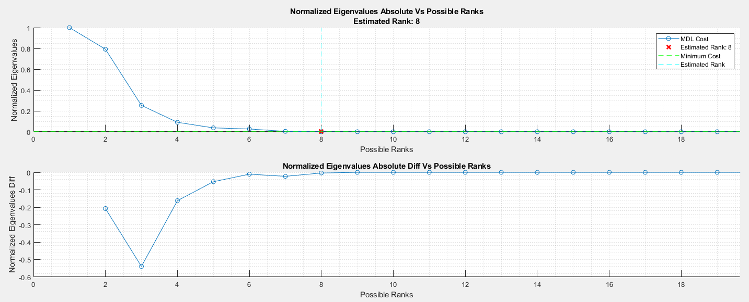

We can see that the strongest eigenvalues are the first 8 eigenvalues, probably belong to the signal taps in 

## Signal and Noise Decomposition

We aim to divide the eigenvalues and eigenvectors into signal subspace and noise subspace.



Because we are further ahead going to invert the signal subspace covariance matrix, we will apply on it the diagonal loading for stability:



## 

## Noise Covariance Whitening

We know that the noise a white Gaussian distributed, therefore its eigenvalues are all supposed to be equal to .

We do not know , therefore we estimate it using the sample mean estimator:



## Peak Thresholding

For almost all the following algorithms we get a power spectrum where we search the strongest peaks for the estimated time delays.

For that we need to define a threshold that will differentiate the noise from the signal peaks.

We will take a CDF percentage that corresponds with the estimated rank of the signal, since we search for that number of peaks.



The threshold will be then:



Where:



We added a median of L to reduce the false alarm.

Example of the thresholding:

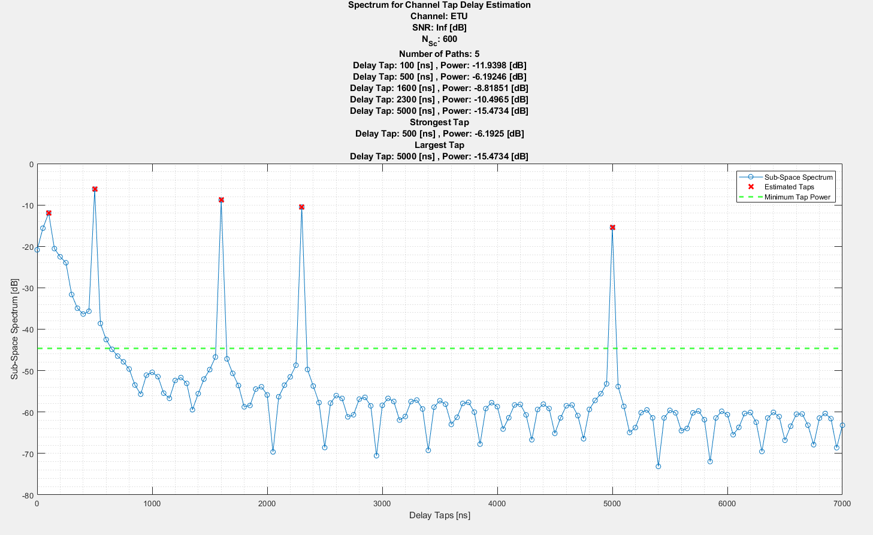

# Delay Spread Estimation Algorithms

## Channel Tap Delays Estimation

### Modified MVDR

The Capon algorithm for optimal beamformer in the means of minimum variance distortionless response, has led us to the following variant.

The original beamformer is of the form:



If we look at a single tap:



Solving with Lagrange multipliers:



Here we wish not to only bring the noise variance to minimum, but to also exploit the data of the signal and locate it with high resolution, therefore we will need the **signal covariance matrix** for that purpose, to focus the optimization on enhancing signal separation and resolution. This approach emphasizes **distinguishing between signals by maximizing the output for the signal of interest** while **minimizing interference from other signals**, leveraging differences in their covariance structures for super-resolution capabilities.

We suggest the following beamformer:



Relying on the fact that the **noise vector is perpendicular to the signal eigenvectors**.



Now we project the beamformer to the input signal :



### MUSIC - Inverse

MUSIC was originally created to find angle of arrival for array processing of antennas. As we mentioned above there is a strong correlation between channel estimation in OFDM to beam steering. The sub-carriers’ function like the receiving elements in phased array.

Beam Steering:



Channel Estimation:





The matrix  is of the form:



Therefore  is **Vandermonde** matrix:



Which means that we can extract the strongest  eigenvalues and refer them to the signal subspace. And the  weakest eigenvalues and refer them to the noise subspace.



We know that the signal is perpendicular to the noise space eigenvectors:



The **null spectrum** will be:



We Will get a peak where the actual signals are because the correlation between the steering vectors and the noise eigenvectors  will be close to 0.

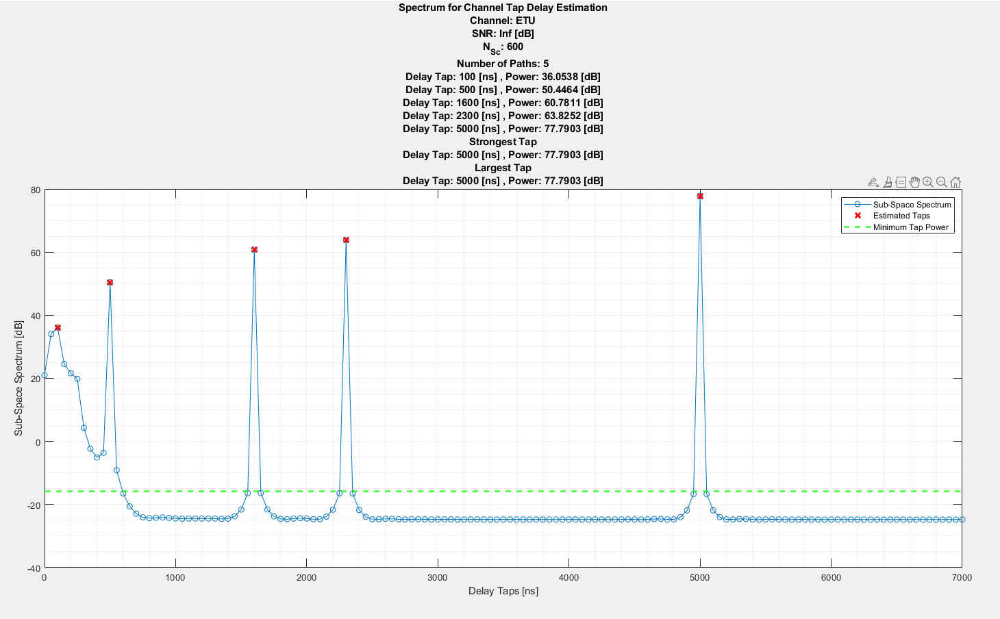

We can see the clean and strong peaks where the signal taps are.

### MUSIC - Roots

To find the roots of the null space we will transform the covariance matrix to real form and look for the roots using the Newton’s Method. We will classify the true roots as the ones inside the unit circle and closest to it.

We take the real of the covariance matrix:



Where  is the real transformation matrix:



The null spectrum:



We find the roots using the Newton’s method:



After we get all the roots, we take the closest  roots to the unit circle



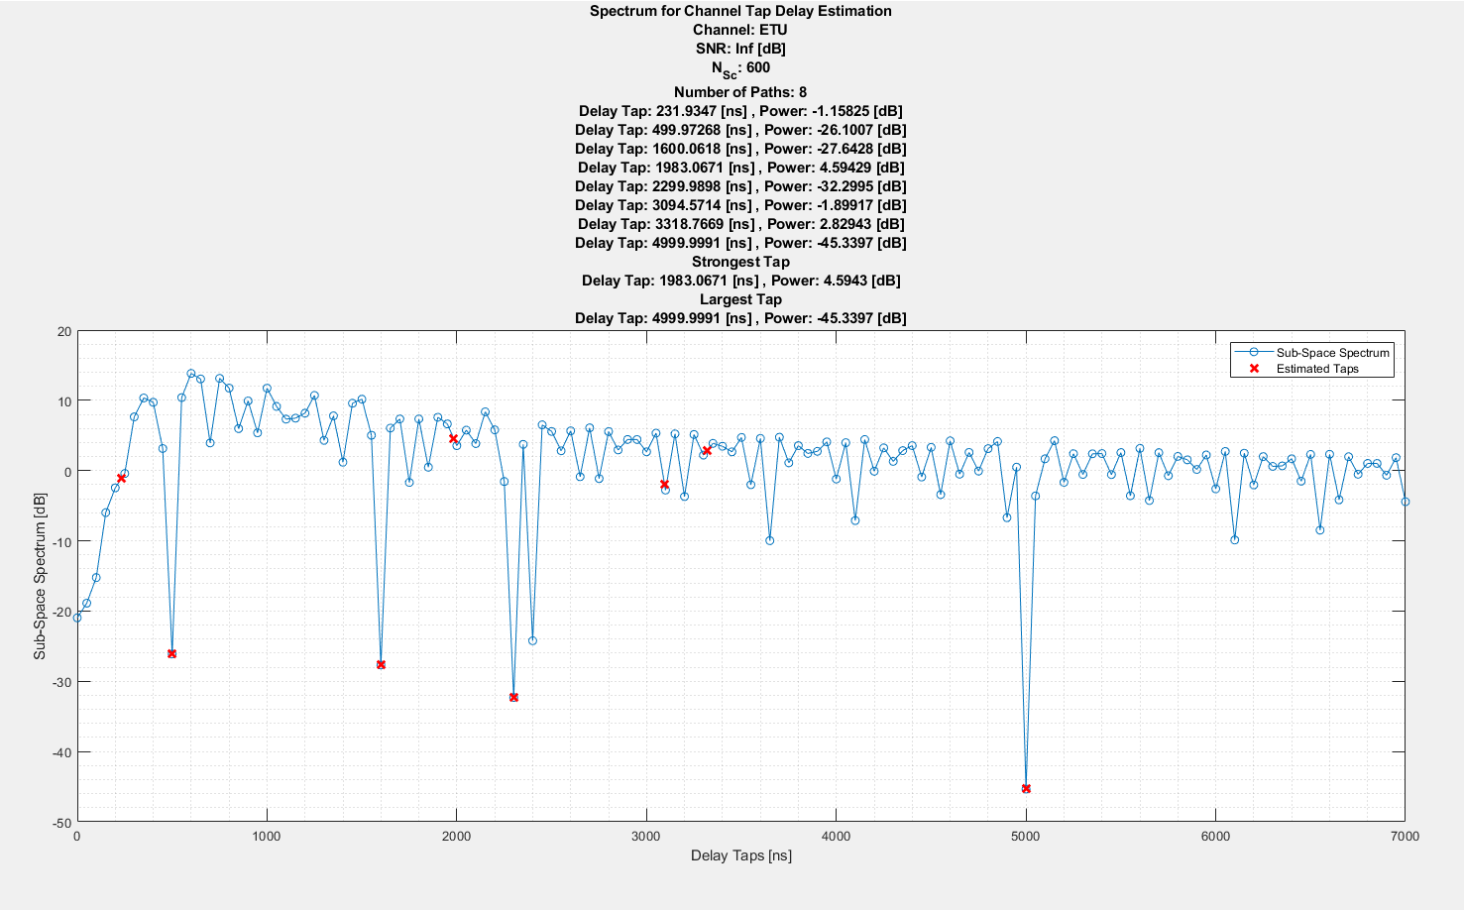

This method is less robust than the inverse version of MUSIC, due to the iterative Newton’s method roots finding and taking only the real part of the covariance matrix, losing the information of the image part.

### ESPRIT

Estimation of signal parameters via rotational invariance techniques.

The ESPRIT algorithm is motivated by the need to estimate the directions of arrival (DOAs) of multiple signal sources with high accuracy and resolution, especially in scenarios where signal sources are closely spaced. ESPRIT exploits the invariance properties of signal subspaces to estimate DOAs without needing to search over all possible directions, significantly reducing computational complexity compared to methods like MUSIC. It's particularly useful in array signal processing applications, offering efficient and precise DOA estimation.

Example of the sensor array division for ESPRIT:

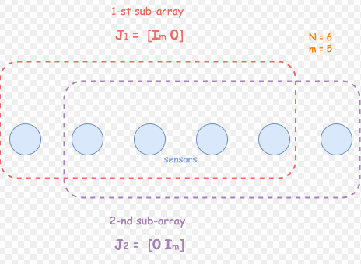

For ESPRIT we need the signal space eigenvectors, and we have it at the output of the signal and noise decomposition block:



We define 2 matrices: 



ESPRIT uses the **rotational information between 2 consecutive subcarriers** to measure the phase shift that was caused by each channel delay tap.



Now we define the matrix as the least squares solution for :



The eigen decomposition of :



Extract the time delay taps from the eigen values of :



This method is very effective since it is not searching a time search space for the signal taps but exploits the mathematical connection of the taps to the eigenvalues of the signal.

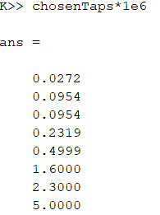

### Modified OMP

The **Orthogonal Matching Pursuit** (OMP) algorithm is an iterative method used for sparse signal recovery, aiming to find the best matching projections of a signal onto a dictionary of basis functions. **OMP selects the dictionary element that is most correlated with the current residual**, adds it to the model, and updates the residual accordingly. This process repeats until a stopping criterion is met, such as a predefined number of iterations or a residual error threshold.

The original OMP algorithm [2], uses the over-complete dictionary of the FFT matrix:



The main objective is to maximize the projection power of the dictionary atoms (the linear phase exponents of the FFT and find the delay time taps of the signal).

Doing that with the **FFT matrix gives us no better resolution than using FFT over the subcarrier’s axes**, so we integrate this approach with the **modified MVDR**, mentioned above for the following algorithm:

First, we define the over complete dictionary:



Now we generate the Modified MVDR W matrix:



Now the OMP algorithm:



We can see that:



The chosen taps are the time output grid in the found indices:



We can see what we would get if we used the original over-complete dictionary using the FFT matrix:

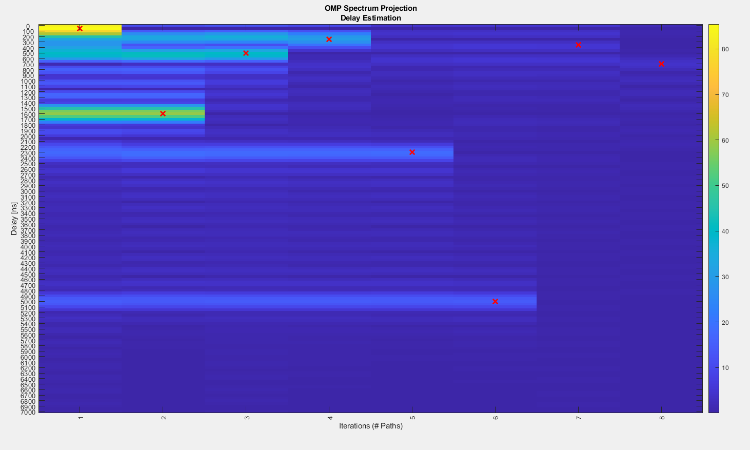

The resolution is the native resolution of the BW we are dealing with:



We can also see the sinc energy that is leaked to the adjacent time bins.

## Channel Tap Phasors Estimation

Now that we estimated the tap delays:  we need to estimate the phasors: 

We get the estimated matrix:



For a single symbol we solve the **least squares** problem:



Now for all symbols:



## Channel Delay Spread Estimation Performance

We measure the RMS of the delay taps for the delay spread estimation:





The measurement of the error will be RMSE (so we still get the units of time in seconds):



# 

# Doppler Spread Estimation Algorithms

For doppler spread estimation we use similar methods to delay spread estimation, but now on the symbols’ axes.

Because we deal here with doppler spread that is spread over a bandwidth we tried calculating the autocorrelation function (ACF) out of the diagonals of the covariance matrix and compare it to the modified Bessel function of order 0: 



The estimation of is done by taking the **sample mean estimator over each of the diagonal lags** of the covariance matrix 

We deal with several methods for doppler spread estimation:

## ACF FFT

As we have done in the above equations’ derivations of the PSF of doppler spread, we apply FFT over the ACF to get the PSD and then we search for the largest peak (furthest in Hz) in frequency to estimate :

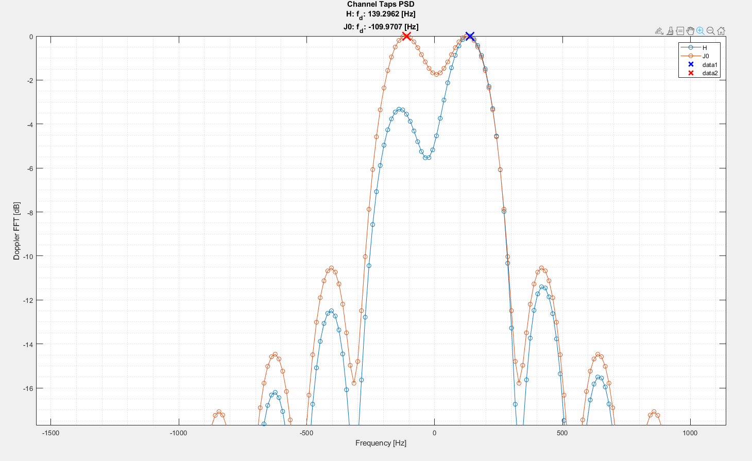

The estimated is 139[Hz] where we simulated 124[Hz], we see also that the  PSD itself gives 110[Hz] which is also not so close to 124[Hz]

## ACF Sub-Space

Like in the delay spread estimation we apply a sub-space algorithm like MUSIC on the ACF and get the above signal spectrum projection power.

We see that we are closer, but we needed to increase the number of symbols by 10 to get that close estimation.

## Estimated Delay Taps Sub-Space

The algorithm we have suggested is the subspace algorithm like in the delay spread estimation, but we are doing it on the estimated taps from the delay estimation stage.

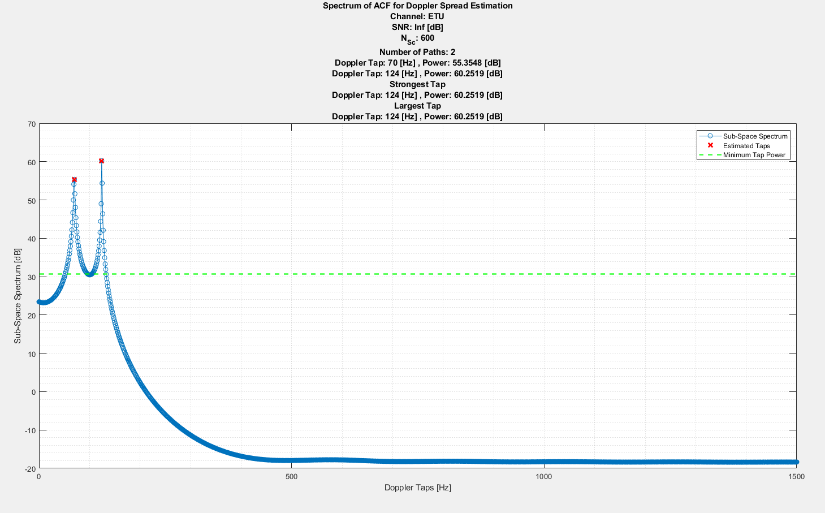

We get exactly 124[Hz] as simulated.

## Channel Doppler Spread Estimation Performance

We measure the doppler spread estimation error by the normalized absolute error from the actual doppler spread:



# References

## [1]: Determining the number of signals by information theoretic criteria

<https://ieeexplore.ieee.org/document/1172389>

## [2]: Channel Estimation for OFDM Signals

<https://repository.library.northeastern.edu/files/neu:cj82pr619/fulltext.pdf>

## [3]: Performance of ESPRIT and Root-MUSIC for Angle-of-Arrival(AOA) Estimation

<https://ieeexplore.ieee.org/document/8690541>

## [4]: Doppler spread estimation in high mobility wireless communication - Zichen Wang

<https://ro.uow.edu.au/cgi/viewcontent.cgi?article=5433&context=theses>